**Name:Mostafa Elsayed Ahmed Nasef**

**B.N:910**

**Date:6/6/2021**

**Topic:Computer architecture**

**Github link:**<https://github.com/Mostafa-Nasef/html.project.repository?fbclid=IwAR2dQpPBdY-p9sgZQaAvEGXKmNon_zVNulQKwUD4cWkUJRSfIyep885-TN0>

**Github page (puplished**):<https://mostafa-nasef.github.io/html.project.repository/?fbclid=IwAR1RI9QoP4D2E6QQL6Aa3XbCacnPFQD3h51rxdcn2ni_hcTZx_xaKacp5gQ>

**Application Brief:**

Computer architecture is a specification detailing how a set of software and hardware technology standards interact to form a computer system or platform. In short, computer architecture refers to how a computer system is designed and what technologies it is compatible with.

I chose this topic to explain what computer architecture is, what are its main subcategories, and how it has evolved over the years

**Screenshots**:

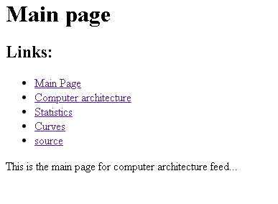

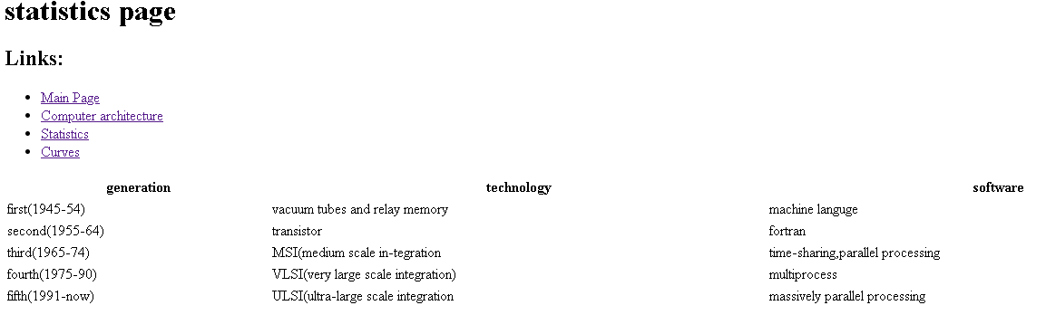

**Source code**:

